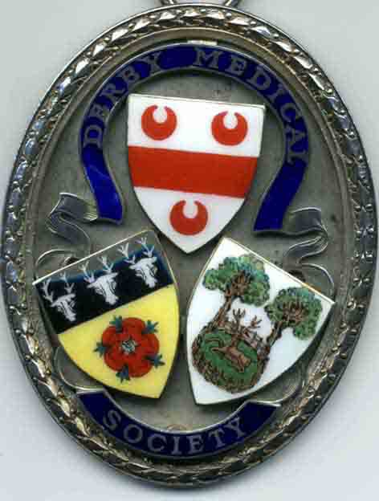
DERBY MEDICAL SOCIETY

Founded in 1862
www.derbymedicalsociety.co.uk

Doctors in Training Poster Presentation Application 2020-21
“The CoVid Season”

Derby Medical Society has a strong history of encouraging and supporting continued learning and professional development.
In the 2018-19 season we introduced an opportunity for doctors in training to display a poster presentation of a research, audit or clinical case review which they have had direct involvement with during their training.
Due to the current CoVid restrictions, we will be displaying posters on the public page of the Derby Medical Society website from Tuesday 5th January through to Wednesday 13th January 2021.
Doctors will have the opportunity to discuss their posters and answer any questions from the attending Society members and their guests.
The poster presentations will be judged and a prize of £250 will be awarded based on the following criteria:
Quality and subject matter of project
Quality improvements identified and action
Presentation of poster
To enter please submit your poster in PDF format to Dr Helen Lever (Council Secretary) at helen.lever@nhs.net. by Monday 4th January 2021. The judging will take place on-line and the winner will be announced at the Case Presentation remote meeting on Wednesday 13th January 2021.

