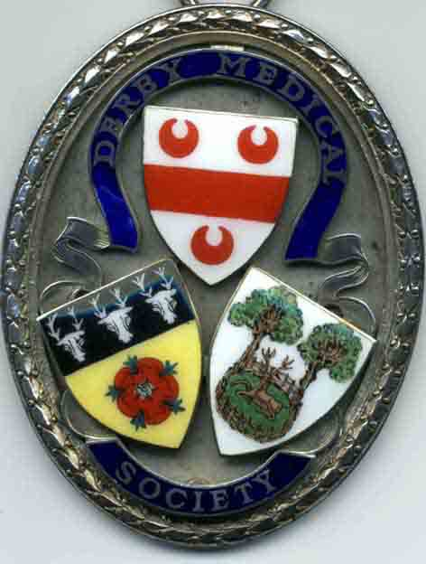
DERBY MEDICAL SOCIETY

Founded in 1862
www.derbymedicalsociety.co.uk

Doctors in Training Poster Presentation Application 2021-2022

Derby Medical Society has a strong history of encouraging and supporting continued learning and professional development.
For the 2021-2022 season we are offering an opportunity for all doctors in training to present posters on research, audits or clinical case reviews with which they have had direct involvement during their training.
This will take place during the ‘Case Presentations, Poster Exhibition & Bursary Awards’ event, starting at 6-30pm on Thursday 13th January 2022 at the Derby Medical School Lecture Theatre.
Posters will be printed in A1 and can be either landscape or portrait in orientation. Presenters will have the opportunity to discuss their posters and answer any questions from the attending Society members and their guests.
The poster presentations will be judged and a prize will be awarded based on the following criteria:
- Quality and subject matter of project
- Quality improvements identified and action
- Presentation of poster
To enter and display a poster during the evening, please submit your poster in a PDF format to Dr Helen Lever (Council Secretary) at helen.lever@nhs.net by 31st December 2021. We will endeavour to ensure that all submissions can be displayed during the evening. Derby Medical Society will print a copy of your poster for display and for you to keep after the evening.
You will be expected to be present during the meeting to answer questions on your poster presentation.
Derby Medical Society offers an annual prize of £250 for the best Poster Presentation.
Please note that you cannot present the same case/research as a poster and a case presentation during the evening.

